Nama : Dhimas Adinata Septyatama

NIM : 2100018287

Hasil mengetik 10 jari

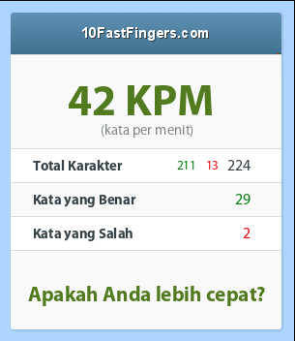

Screenshot repo GitHub

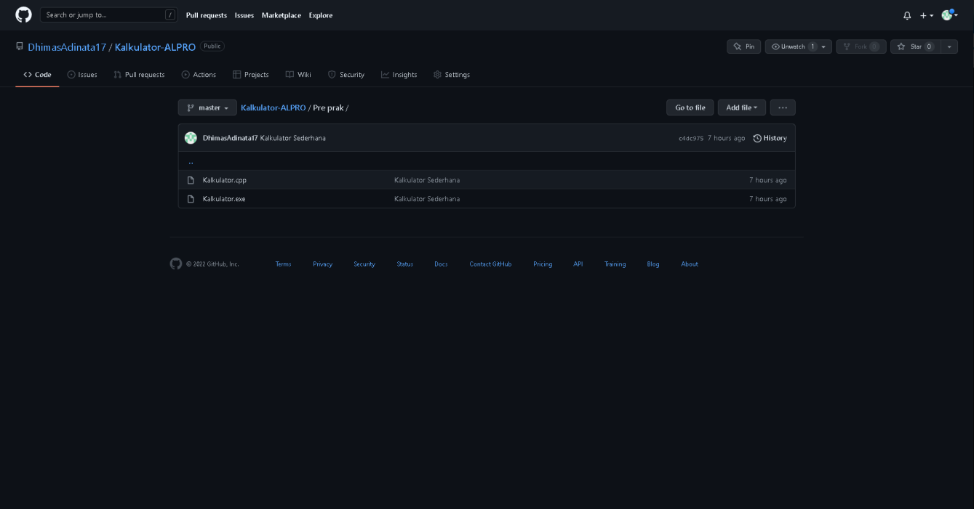

https://github.com/DhimasAdinata17/Kalkulator-ALPRO/tree/master/Pre%20prak